Instructions for abstract preparation for EAC2023

J.L. First¹, P.L. Second² and J.C. Third²

¹Department of Aerosols, University of Somewhere, City, Postcode, Country
²Department of Particulate Matter, National Research Centre, City, Postcode, Country
Keywords: first, second, third, fourth, fifth.
Associated conference topics: 2.4, 1.6, 3.5 (up to three conference topics for review and allocation)
Presenting author email: j.first@somewhere.edu

Please use this template for abstract preparation and submit your abstract in .pdf format.
The abstract should be in double column (like this example) and ONE page long (any additional page will be automatically deleted). Use A4 page set-up and make all margins (top, bottom, left, right) 20 mm wide. Use 10 pt Calibri font (except for the title which should be in 12 pt bold and in sentence case). Centre the title, the authors’ names, the addresses, keywords, conference topics and contact email address. Please compose a title that clearly and succinctly describes the content of your work, in order to maximise its impact.
Start each paragraph, except the first, with an indent. Justify the body of the text both left and right. Do not use page numbers. Keywords and listing of associated topics are there to draw attention to your abstract, and to help the organisers allocate the abstract to the most appropriate reviewers and conference session.
Use clear English to write your abstract, with an emphasis on describing what is new and why it should attract the attention of the audience.
Figures can be in colour or in black and white. Ensure that Figures and Tables have a caption and that they are numbered consecutively.

Table 1. Comparison between theoretical predictions and experimental measurements.
Month | Measured density (μg/m3) | Predicted density (μg/m3)
Feb | 0.4 | 0.4711
Jun | 2.4 | 1.528×10⁴

References should be made in the style (Rosner, 2000), Fernandez de la Mora and Kozlowski (2013) or as Neubauer et al (2010). Examples of references are shown below. Leave a blank line above the list of references, and also above the acknowledgements.
Section headings can be used, but they do take up valuable space: the same can be said of equations.

Abstract review
- Abstracts will be reviewed by the Program Committee (chairs and co-chairs of the EAA working groups). Abstracts which do not fulfil the standards will be rejected. Please avoid submitting abstracts containing only future results.
- Accepted abstracts will be placed on the conference website/app and provided to conference attendees. Abstract titles and author lists will be listed in the conference handbook/app.
- Participants should not make requests for oral presentation of several papers on similar subjects. We recommend submitting only the most general paper for oral presentation and the others for poster presentation.
The abstract should be submitted through the EAC2023 website: www.dfmf.uned.es/EAC2023 in pdf format.
The deadline for abstract submission is February 28, 2023. Pease try to submit the abstract well in advance to avoid last moment troubles.

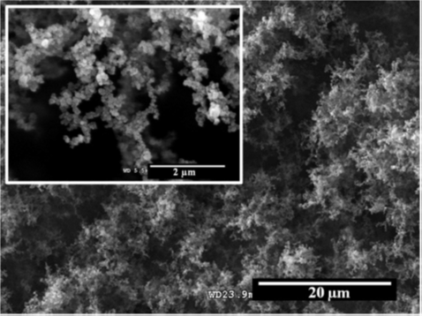

Figure 1. Upper view SEM micrograph of a dry ES deposit formed by carbon nanoparticles.

This work was supported by the National Council for Aerosol Research under grant JC/2102.

Fernandez de la Mora, J. and Kozlowski, J. (2013) J. Aerosol Sci. 57, 45-53.
Neubauer, N., Seipenbusch, M. and Kasper, G. (2010) Proc. European Aerosol Conference, EAC2010, Granada.
Rosner, D.E. (2000) Transport Processes in Chemically Reacting Flow Systems. Dover Publications.

